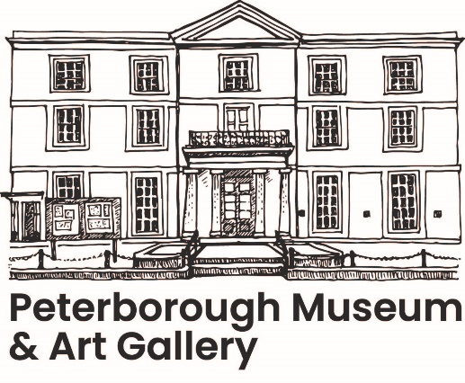**Research Visit Request Form**

To access Peterborough Museum & Art Gallery’s stored collections please complete this Research Visit Request form and return it to [Museum@peterboroughlimited.co.uk](mailto:Museum@peterboroughlimited.co.uk)

Please ensure you have read the conditions provided on this form. Researchers will be required to provide valid photographic identification on their first visit.

|  |  |  |  |  |  |
| --- | --- | --- | --- | --- | --- |
| **Date of request submission** | |  | | | |
| **Name** |  | | | | |
| **Email** |  | | **Phone** |  | |
| **Address** |  | | | | |
| **Project name** (if applicable) | |  | | | |
| **Proposed date/dates of visit** | |  | | **Total hours required** (approx.**)** |  |
| **Research affiliation** (institution/employer/funder if applicable) | | | | | |
| **Research proposal** (what do you want to achieve/ learn from our material?): | | | | | |
| **Research purpose** (family history, academic research, object study, technique study, publication, commercial etc.) | | | | | |
| **Archive, collection, material or subject to be studied** (please be specific. If known give item name, type, document titles, sites, dates, creator, make, material, event, accession number etc.) | | | | | |
| **Specific access requirements** | |  | | | |
| I confirm that I have read and agree to abide by the Research Visit Conditions provided on this form.  **Signature of researcher:**  **Signature of staff:** | | | | | |

**Research Visit Conditions**

1. Access to collections is at the discretion of Peterborough Museum & Art Gallery (PMAG) and by appointment only. PMAG reserves the right to restrict or prohibit access to collections at any time without notice.

2. To protect the collections PMAG reserves the right to limit the duration of your visit and the number of objects, archive records or books you can view.

3. PMAG reserves the right to deny access to friends/relatives or anyone accompanying a researched unless those people are named on this form.

4. Photographic identification will be required on your first research visit to PMAG.

5. Visitors must comply with all emergency procedures, including the evacuation of the building in the event of a fire, or for fire drills.

6. Bags and coats are not permitted in study areas, a member of staff will direct you to a secure location they can be left or provide locker storage.

7. Visitors will be invigilated by a member of staff at all times whilst in study areas.

8. Smoking, eating, drinking or chewing gum is not permitted anywhere in the study area, or outside of designated zones within PMAG.

9. Notes may be made using pencils or personal computers only. The use of pens, paints, glues or any other substance or equipment that may damage the collections is not permitted. Access to a computer may be provided, for which there may be a charge.

10. In order to safeguard collections visitors must not touch or handle objects without express consent from a supervising member of staff. If consent is given they must be handled as instructed and not marked or interfered with in any way including changing ordering.

11. Archive records and books may be handled but only with great care, visitors must not mark, lean on, or interfere with the original order of material. All handling instructions given must be followed.

12. Consideration must be shown to other users and staff throughout your visit. You may use mobile phones for texting or taking photographs, subject to conditions 13 & 14. Mobile phones must be switched to silent/vibrate off whilst in study areas.

13. Reproductions of collections, including by photography and filming, may be permitted at the discretion of the supervising member of staff for private study and non-commercial research only, subject to copyright legislation and other restrictions. Reproductions are not permitted for publication (including the internet). An Agreement for Non-Professional Reproduction of Objects must be completed before reproduction commences.

14. The photocopying of archive records and books may be permitted subject to additional charges and the terms of condition 13 above. Please ask a member of staff for our up to date Archive and Collection charges.

15. Commercial reproductions of collections are subject to different conditions and charges. Please ask a member of staff for our Terms and Conditions for the Reproduction of Peterborough Museum and Art Gallery Material.

16. The Museum must be acknowledged in any research based on material from the collection, wording will be provided on request. If a copy of research based on material from the collections is requested this must be supplied.

17. Additional conditions and handling charges may apply depending on the store visited, collection examined or for funded/commercial projects.

18. Peterborough Museum and Art Gallery will hold and process your data in accordance with the Data Protection Act 2018 and the General Data Protection Regulation. I understand that PMAG will keep a record of my contact details in accordance with its Records Retention Schedule, but will not pass these details on to any third party without my permission, other than where we are required to by law. Please see the Privacy Notice on our website for more information <https://peterboroughmuseum.org.uk/privacy-policy>.

If you have any queries, please contact: [museum@peterboroughlimited.co.uk](mailto:museum@peterboroughlimited.co.uk)